4. Binary Search Trees and Postfix Expressions
Aim:
Evaluation of postfix expressions using trees.

Theory:
1. Binary Search Trees
A binary search tree is a tree that is organized as a binary tree i.e. all nodes can have at max, 2 children.
Along with the binary tree properties, a Binary Search Tree also has certain properties of it’s own:
a. For every node x in the Binary Search Tree:
- Every node y in it’s left-subtree should be such that y.key < x.key
- Every node z in it’s right-subtree should be such that z.key > x.key
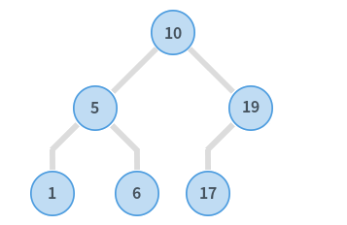

Fig 1. Example of BST
In the above example, for the root node 10, it’s left sub-tree contains the nodes 5, 1, and 6, all of which are less than 10. Similarly, it’s right sub-tree contains the nodes 19, and 17, both of which are greater than 10.
This property is called as binary-search-tree property.

2. Creating a Binary Search Tree And Inserting Elements
We create a Binary Search Tree by representing each element in the tree as an object, containing 3 important attributes:
- data: denotes the key stored in that node
- lc: points to the left child of the node
- rc: points to the right child of the node
While inserting new elements into the binary search tree, we need to ensure that the tree stays organized as a binary tree, and at the same time, also satisfies the binary-search-tree property.

3. Creating an Expression Tree from Postfix Expression
Expression tree is a binary tree in which each internal node corresponds to an operator and each leaf node corresponds to an operand.
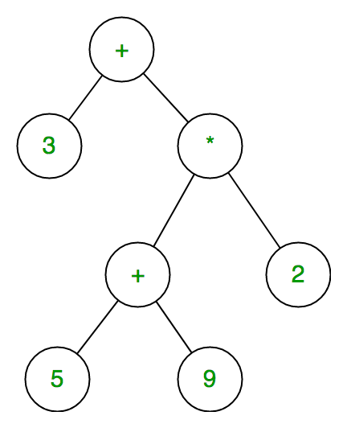

Fig 2. Example of Expression Tree
Given a postfix expression of the form: A B +
we can create an expression tree by following the below algorithm:
1. Push operands(A, B) on a stack as leaf-nodes, not bound to any tree in any direction
2. For operators (+), pop the necessary operands off the stack, create a node with the operator at the top, and the operands as child, and push the new node onto the stack
4. Evaluation Of An Expression Tree
After a Binary Expression tree for a given postfix expression is formed, it can be easily evaluated.
Since, in the Binary Expression tree, leaf nodes are always operands, non-terminal nodes are operators, and each node can have only 0 or 2 children, we can follow the below algorithm to evaluate the expression tree, in post-order fashion:
1. Recursively evaluate the left sub-tree and right sub-tree
2. If data is encountered in a node, push it onto the stack.
3. If an operator is encountered, pop the top two elements from the stack,
a. element at top: right operand
b. element at top-1: left operand
perform left operand ( operator ) right operand and push the result onto the top of stack.

Implementation:

1. Creating a BST and Inserting Elements Into It
#include<stdio.h>
#include<stdlib.h>
//Program for creation and insertion of nodes in Binary Search Tree
struct Node {
int data;
struct Node* lc;
struct Node* rc;
};
struct Node* root;
struct Node* temp;
struct Node* pos;
void createNode(int data) {
int compare = 0;
printf("\nCreating data node %d",data);
struct Node* node = (struct Node*)malloc(sizeof(struct Node*));
node->data = data;
node->lc = NULL;
node->rc = NULL;
if(root == NULL) {
printf("\nRoot is empty, setting root to data node %d",node->data);
root = node;
}
else if(root != NULL) {
printf("\nRoot is not null, trying to find terminal node where data node %d will be attached",node->data);
pos = NULL;
temp = root;
while(temp != NULL) {
compare = temp->data;
if(data < compare) {
printf("\nMOVED LEFT");
pos = temp;
temp = temp->lc;
} else {
printf("\nMOVED RIGHT");
pos = temp;
temp=temp->rc;
}
}
printf("\nTerminal Node to which data node %d will be attached is found as %d",node->data,pos->data);

//Determine whether new node will be attached as left child or right child of terminal node
if(data < pos->data) {
printf("\nNew node attached as left child of %d node",pos->data);
pos->lc = node;
} else {
printf("\nNew node attached as right child of %d node",pos->data);
pos->rc = node;
}
}
}
void inorder(struct Node* start) {
if(start != NULL) {
inorder(start->lc);
printf("%d\t",start->data);
inorder(start->rc);
}
}
void main() {
int data,ch;
printf("\nPress 1 to enter a node and 0 to exit");
scanf("%d",&ch);
if(ch == 1) {
do {
printf("\nEnter data for the node");
scanf("%d",&data);
createNode(data);
printf("\nPress 1 to enter a node and 0 to exit");
scanf("%d",&ch);
} while(ch != 0);
}
printf("\n--------------BINARY SEARCH TREE IN IN-ORDER--------------");
printf("\n");
if(root == NULL) {
printf("\nTREE IS EMPTY");
} else {
inorder(root);
printf("\n");
}
}

Output
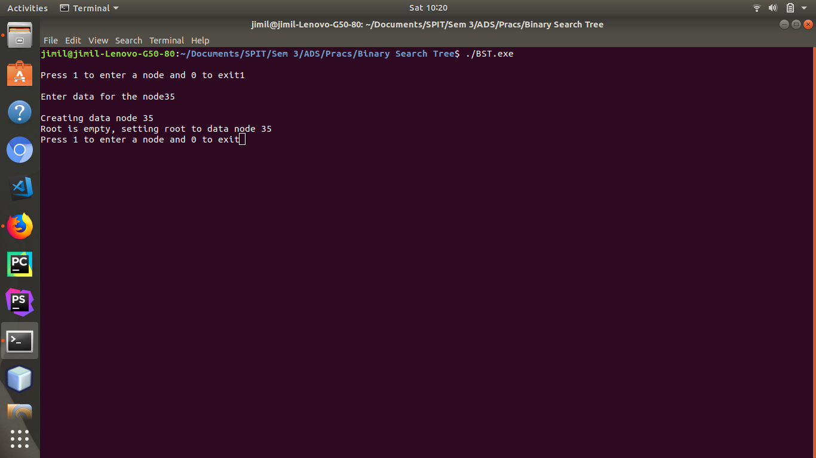
Fig 3.1. Entering the root node
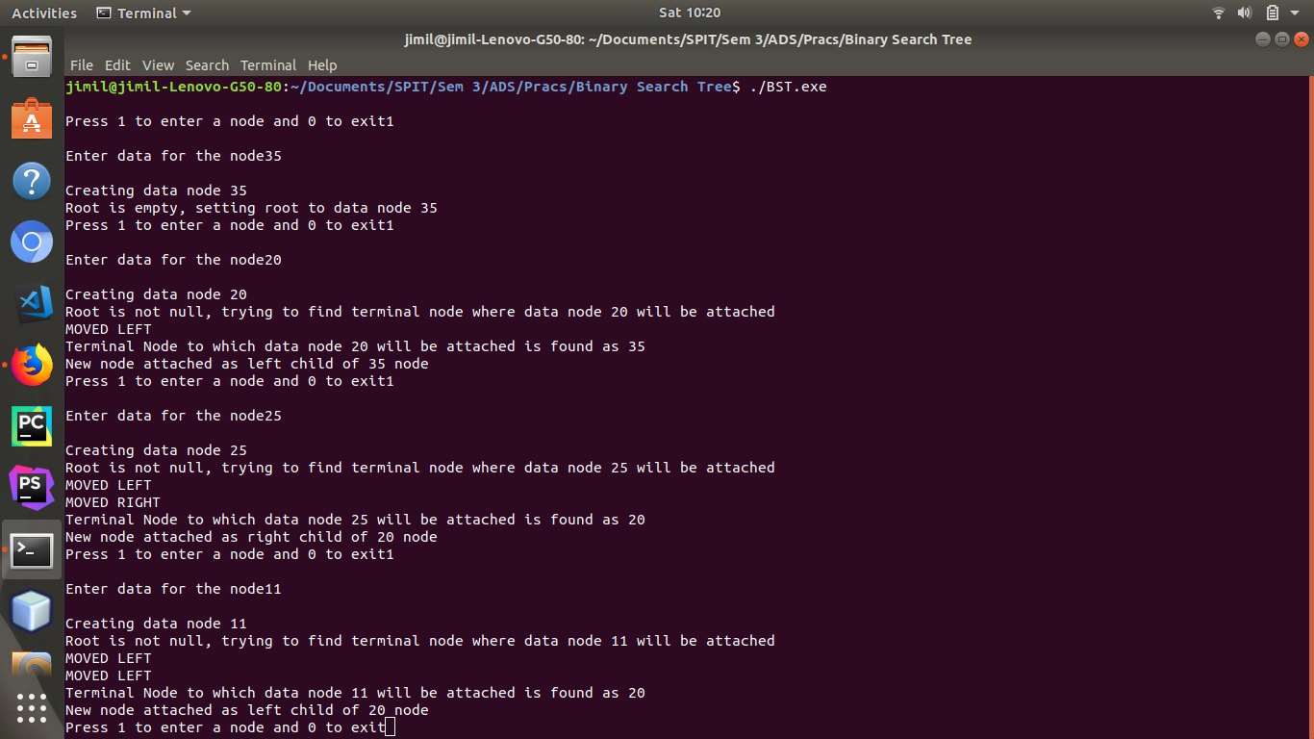
Fig 3.2. Creating the left sub-tree

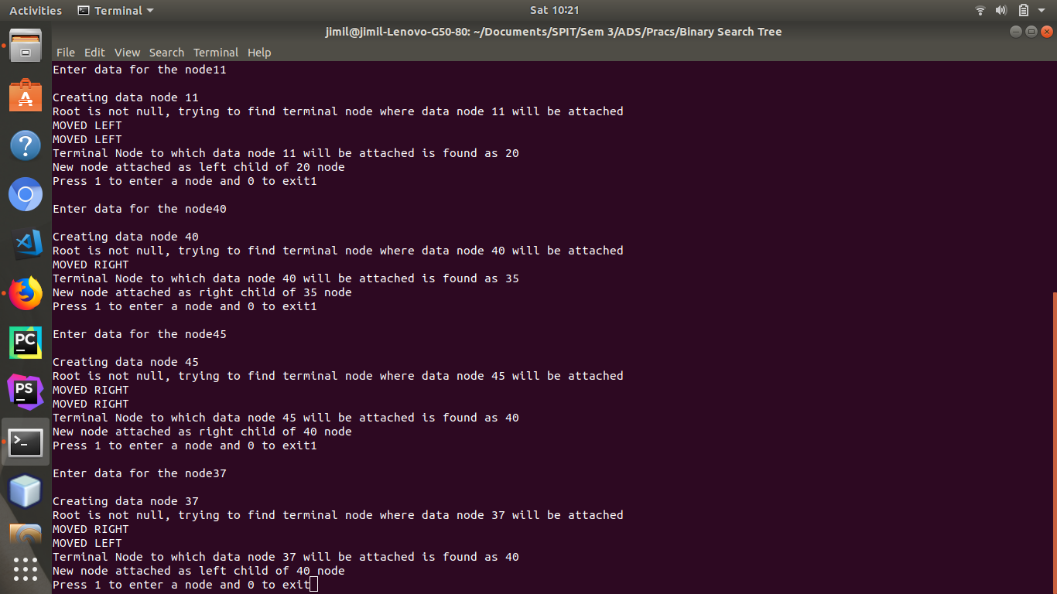
Fig 3.3. Creating the right sub-tree
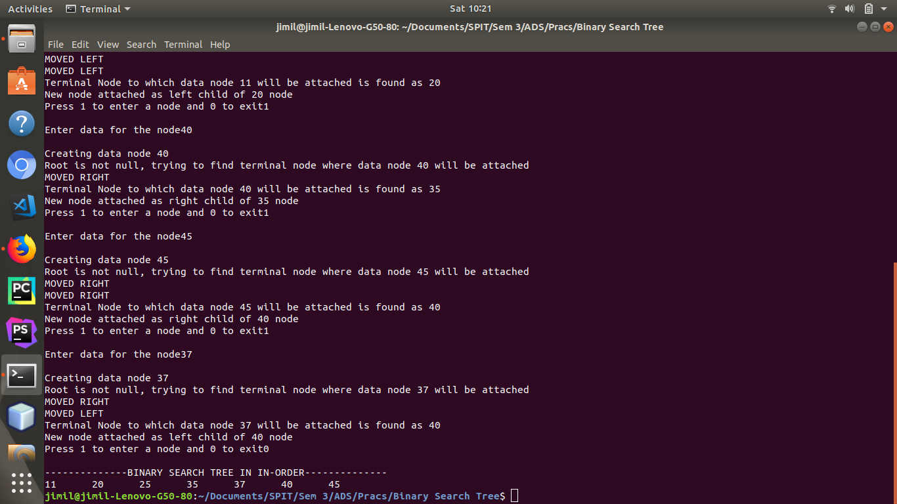
Fig 3.4. In-order traversal of the created Binary Search Tree

2. Evaluation of Postfix Expression using Expression Tree
#include<stdio.h>
#include<stdlib.h>
#include<math.h>
struct Node {
int data;
char op;
struct Node* lc;
struct Node* rc;
};
struct Node* root;
struct Node* stack[20];
struct Node* newNode;
struct Node* tempNode;

char postfix[20];
int stk[20];
int top=-1;
int top1=-1;
int rightOp = 0;
int leftOp = 0;

void pushInt(int data) {
printf("\nPushing data %d",data);
top++;
stk[top] = data;
}
int popInt() {
int data;
printf("\nData to be popped %d",stk[top]);
data = stk[top];
top--;
return data;
}
void pushNode(struct Node* node) {
printf("\nPushing operator node %c",node->op);
top1++;
printf("\nValue of top = %d",top1);
stack[top1] = node;
}
struct Node* popNode() {
struct Node* anotherTemp = stack[top1];
printf("\nPopping node with operator %c",anotherTemp->op);
printf("\nValue of top = %d",top1);
top1--;
return anotherTemp;
}
void inorder(struct Node* start) {
if(start != NULL) {
inorder(start->lc);
if(start->data != 0) {
printf("%d\t",start->data);
}
else {
printf("%c\t",start->op);
}
inorder(start->rc);
}
}

void postordereval(struct Node* start) {
if(start != NULL) {
postordereval(start->lc);
postordereval(start->rc);
//If data encountered, push it onto int stack
if(start->data != 0) {
pushInt(start->data);
}
else {
rightOp = popInt();
leftOp = popInt();
switch(start->op) {
case '+' : pushInt(leftOp + rightOp);
break;
case '-' : pushInt(leftOp - rightOp);
break;
case '*' : pushInt(leftOp * rightOp);
break;
case '/' : pushInt(leftOp / rightOp);
break;
case '%' : pushInt(leftOp % rightOp);
break;
}
}
}
}
void main() {
int i;
struct Node* right;
struct Node* left;
int r, l;
int occurence = 0;
printf("\nEnter the postfix expression");
scanf("%s",postfix);
i=0;
while(postfix[i] != '\0') {
if((int)postfix[i] >= 48 && postfix[i] <= 57) {
pushInt((int)postfix[i]-(int)48);
}
else if(postfix[i] == '+' || postfix[i] == '-' || postfix[i] == '/' || postfix[i] == '*' || postfix[i] == '%') {
if(occurence == 0) {
r = popInt();
l = popInt();
right = (struct Node*)malloc(sizeof(struct Node*));
right->data = r;
right->lc=NULL;
right->rc=NULL;
left = (struct Node*)malloc(sizeof(struct Node*));
left->data = l;
left->lc=NULL;
left->rc=NULL;
newNode = (struct Node*)malloc(sizeof(struct Node*));
newNode->op = postfix[i];
newNode->lc = left;
newNode->rc = right;
occurence++;
pushNode(newNode);
}
else if(occurence > 0) {
tempNode = popNode();
r = popInt();
right = (struct Node*)malloc(sizeof(struct Node*));
right->data = r;
right->lc=NULL;
right->rc=NULL;
newNode = (struct Node*)malloc(sizeof(struct Node*));
newNode->op = postfix[i];
newNode->lc = tempNode;
newNode->rc = right;
occurence++;
pushNode(newNode);
}
}
i++;
newNode=NULL;
tempNode=NULL;
left=NULL;
right=NULL;
}
root = popNode();
printf("\n-------------IN-ORDER EXPRESSION-------------\n");
inorder(root);
printf("\n");
top=0;
for(i = 0; i < 20; i++) {
stk[i] = 0;
}
postordereval(root);
printf("\nResult of Eval : %d\n",popInt());
}

Output
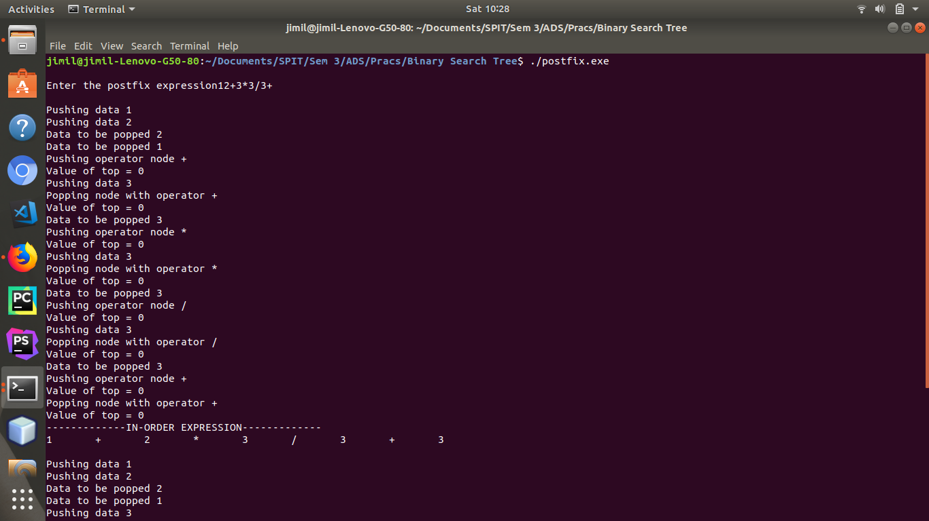
Fig 4.1. Entering the postfix expression and creating the expression tree

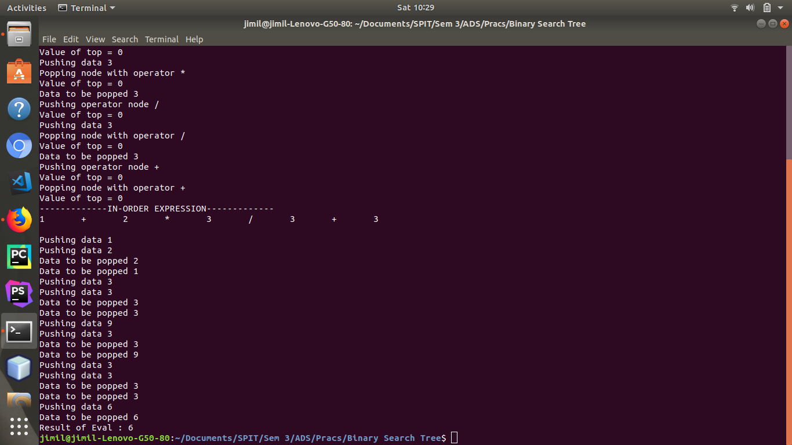
Fig 4.2. Evaluation of expression tree

Result:
We created a Binary Search Tree, and observed that it’s in-order traversal, caused elements to be traversed in an ascending order. This was because of the binary-search-tree property.
We also created an expression tree from a given postfix expression, and observed that its in-order traversal gave us the infix expression. We then used the expression tree to evaluate the given postfix expression.

Conclusion:
Thus, we have understood and implemented the concept of Binary Search Trees, and used it to create an expression tree and evaluate a given postfix expression.

